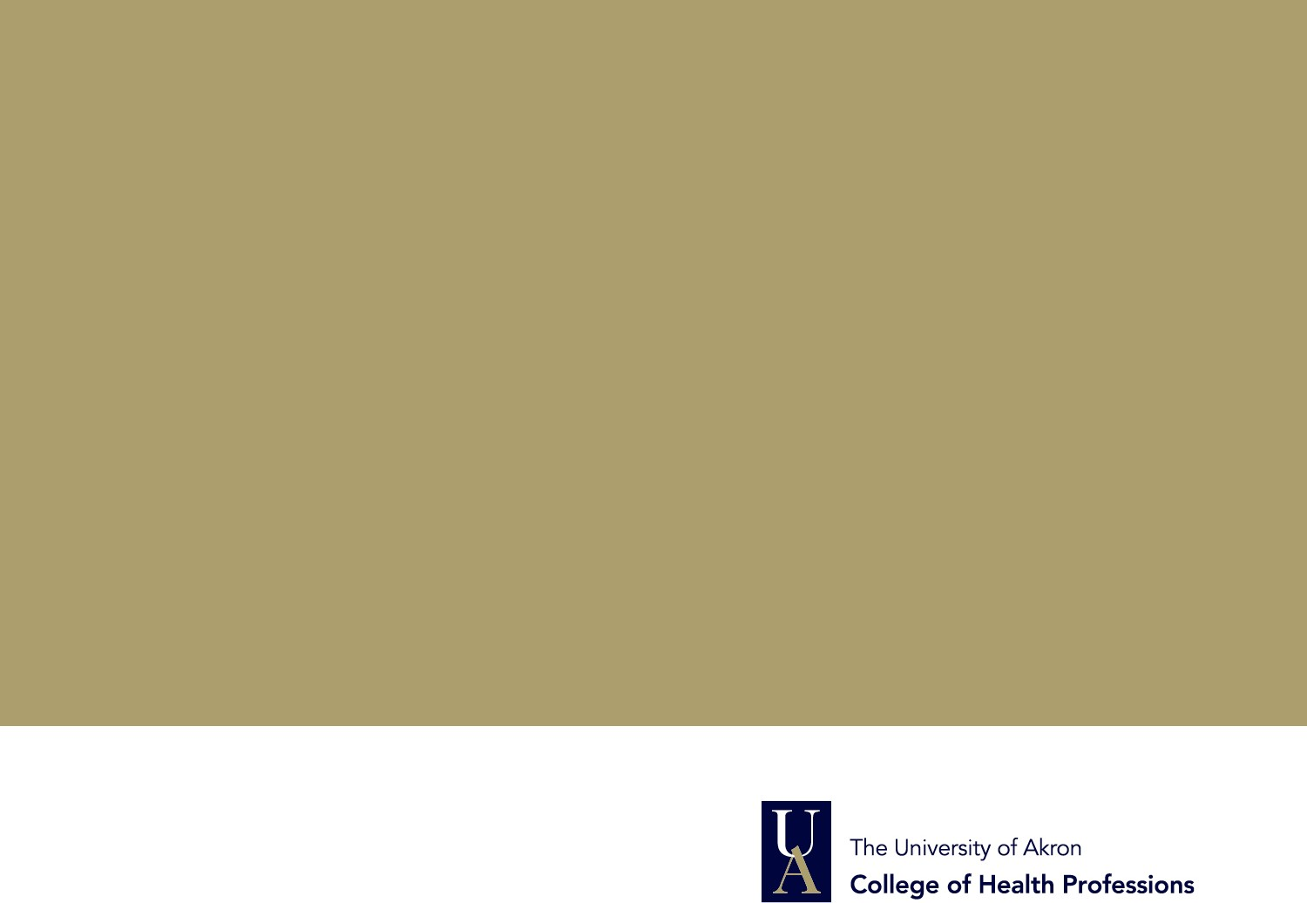

Field Education Structure | Design | Undergraduate
- Two consecutive semesters in same agency
- Required Field education hours |225 hrs. per semester| 450 total
- Fall/Spring – 15 hours per week | 15 weeks
- Summer- 10 weeks: 22.5 hours per week
- Summer- 13 weeks: 17.5 hours per week
- 3 credit hours per semester for Field Education | 6 credit hrs. total | Grade A-F
- 1 hour of weekly F2F supervision with Field Instructor
- 1 mandatory visit to agency by Faculty Field Liaison per semester | 2x per academic year
- Learning Activities – 1x per AY | Baseline Assessment – 1x per AY |Student Evaluation – 2x per AY | Hours Log & Narrative Log – monthly submission

http://www.uakron.edu/socialwork/field-education/basw-info-forms.dot/

Courage. Compassion. Competence
School of Social Work

